EXPERIMENT 8
CREATE TABLE Bank ( bankcode VARCHAR(3) PRIMARY KEY, bankname VARCHAR(50) NOT NULL, headoffice VARCHAR(50), branches INT CHECK (branches > 0));

INSERT INTO Bank VALUES ('B01', 'SBI', 'Ernakulam', 100);
INSERT INTO Bank VALUES ('B02', 'HDFC', 'Kottayam', 45);
INSERT INTO Bank VALUES ('B03', 'ICICI', 'Ernakulam', 60);
INSERT INTO Bank VALUES ('B04', 'AXIS', 'Trivandrum', 30);
INSERT INTO Bank VALUES ('B05', 'PNB', 'Kozhikode', 70);

CREATE TABLE Branch ( branchid INT PRIMARY KEY, branchname VARCHAR(50) DEFAULT 'New Delhi', bankid VARCHAR(3), FOREIGN KEY (bankid) REFERENCES Bank(bankcode));

INSERT INTO Branch VALUES (1, 'Kottayam', 'B01');
INSERT INTO Branch VALUES (2, 'Ernakulam', 'B01');
INSERT INTO Branch VALUES (3, 'Kottayam', 'B02');
INSERT INTO Branch VALUES (4, 'Trivandrum', 'B03');
INSERT INTO Branch VALUES (5, DEFAULT, 'B04'); -- uses default 'New Delhi'
INSERT INTO Branch VALUES (6, 'Kottayam', 'B05');

1)CREATE VIEW bank_head_office AS SELECT * FROM Bank WHERE headoffice = 'Ernakulam';
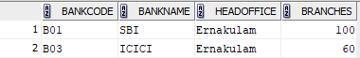

2)CREATE VIEW bank_branch AS SELECT DISTINCT b.*FROM Bank b JOIN Branch br ON b.bankcode = br.bankid WHERE br.branchname = 'Kottayam';
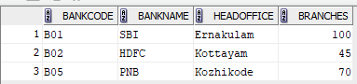

3)CREATE VIEW bank_more_than_50 AS SELECT *FROM Bank WHERE branches > 50;
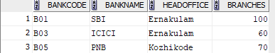

4)CREATE VIEW bank_branch_details AS SELECT b.bankname, br.branchname FROM Bank b JOIN Branch br ON b.bankcode = br.bankid;
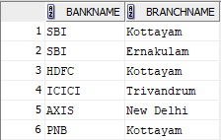
5)CREATE VIEW bank_outside_ekm AS SELECT * FROM Bank WHERE headoffice <> 'Ernakulam';